SBScope help
CBScope is an application developed by Cyrille de Brébisson and designed to help you design/build a Dobsonian type telescope.
CBScope main features are basic scope values calculations (Radius Of Curvature, Focal Length), more advanced ones such as focal plan illumination, mirror making logs and, hopefully mirror cell and parabolization help.
Note: all units are assumed to be in millimeters and minutes!

The UI (crap looking, I know) has 3 main elements.
On the bottom left (in red here), you have a selection box that allows you to select the telescope that you want to work on. An Add and a Delete button next to it allows you to add more scopes to your list of erase the current scope.
On the bottom right (in yellow here), you have a number of buttons that allows you to focus on a given part of the scope design. The details of which will be shown on the main part of the window.
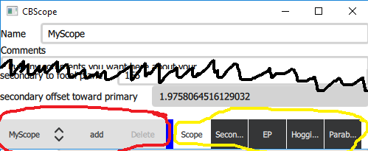

The scope specification page
On this page you will enter all the basics of your scope. Name it (if you want, but if you leave the “default” and start creating more scopes, you will have a number of “default” in the selection box).
Add comments if you want to (they can be multi line).
Enter the main mirror diameter and focal information. Note that you can enter the focal as a length, a F ratio or a RadiusOfCurvature. Internally, the focal is stored as a length. The system will automatically calculate the sagita and volume that needs to be removed from the mirror to make it spherical.
Enter the secondary small diameter and the distance from the secondary to the focal plane (ie, distance from the primary optical axis and the eyepiece). The system will automatically calculate the offset of the secondary toward the primary for perfect collimation.

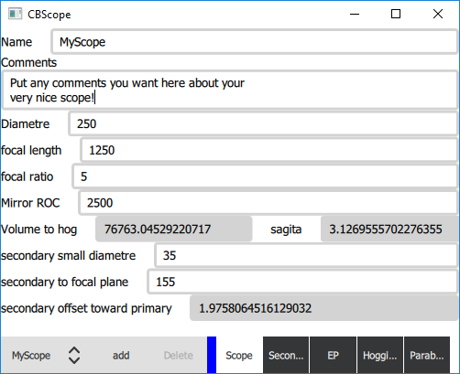

The Eyepeice page
This page lets you specify your eyepeices.
Add a new eyepiece by filling the fields at the botom and pressing the add button. You can delete the currently selected EP by pressing the Delete button.
Note that you can always modify an EP by just selecting it and changing the values in the list.
Once again, the system automatically calculates a number of information for the EP such as the field size (the size of the focal image that it shows to the eye), the zoom factor and the real viewed angle (which depends on the scope focal length).
The delete button allows you to delete the currently selected EP.
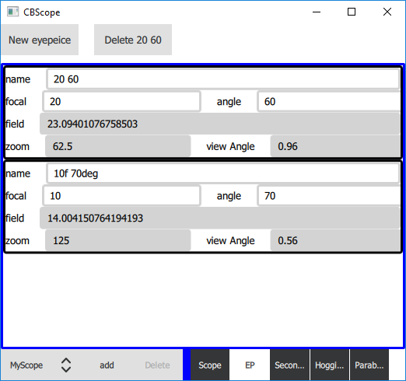

The secondary sizing page
This page is designed to help you select a secondary and contains a lot of information!
On the top, enter the list of all the secondary sizes that you are considering for this scope (separate each entry by a space).
The graph will display a curve for each of the secondaries that are viable for this scope (secondaries that are too small will not be shown, secondary that are too large will also not be shown).
How to “read” the graph?
The horizontal axis represents the diameter of the image formed on the focal plan by the telescope. On the right side, it is indicated in millimeters. On the left side it is indicated as a real view angle (what angle of the sky you see at this distance from the optical axis).
The vertical axis represents the amount of light gathered by the primary that makes it to the focal plane at a given distance from the optical axis. You can never get 100% as the secondary will hide some of the light. The bigger the secondary, the more it will hide. The graduation on the left side is in magnitude loss (anything below 0.4 is barely noticeable by the eye). The graduation on the right size is in %.
The curves (color coded with the secondary sizes displayed on the top left) will tell you, for each secondary size, how much light they put at a given distance from the optical axis. A small secondary will have a maximize the illumination, but only close the optical axis (ie at high zoom). A large secondary will be less illuminated at high zoom but will offer better wide views. Pick your poison!
To help you choose, the top right will display the names of your various eyepiece and show you as straight lines (at the top of the graph), the area of the focal image that is “imaged” by the eyepiece. Here, as you can see the 63mm secondary meshes well with my 20mm, 60° EP.
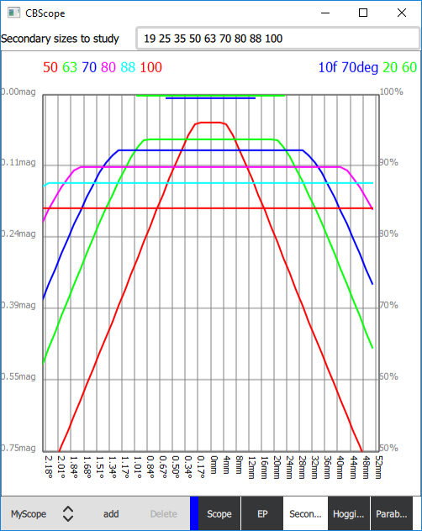

Hogging page
The hogging page is there to help you during the initial mirror grinding phase. The phase were you dig the sphere in your mirror.
On the top, you can specify your home made spherometer parameters. Assuming that you have made a home made spherometer with 3 legs and a micrometer, calculate the average distance between the legs and enter them on the top. This will we be used to translate micrometer readings into radius when you click on the “Spherometer reading” button to create a new “hogging work”.
The aim of this page is to let you follow your progress while hogging the sphere. During the hogging process, each time you stop to do a reading, enter the time it took, the reading and the grit used. Click “Spherometer reading” if you are using a home made spherometer (it will calculate the ROC using the h/2+L²/(6*h) formula where h is the reading and L the average distance between the legs). Click on “radius reading” if you have a tool that measures the radius directly. In each cases a new “hogging work” will be added to the list (you can always modify them later).
One again, the system will automatically calculate a bunch of stuff for you. The amount of material hogged per unit of time (hog/time), and the end sagita. It will also calculate (at the bottom) an estimation of the amount of time left hogging if using the “grit” (it does it by averaging the hog/time of all the hogging work using that same grit). It gives you a “done %” and tells you how much there is to hog total, and how much is left to hog.
